Answer 4
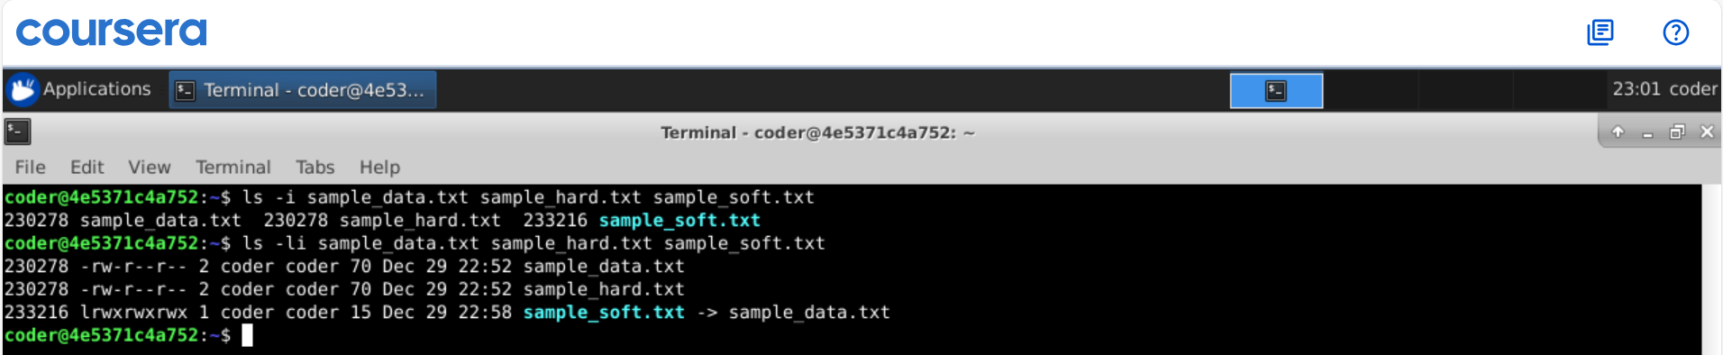
Explanation: Using ls command with -I option will show the Inode number. To use it followed by the file names if you want inode number for specific files. Also using -l option with I gives detailed view with permission and Inode number together.

